 : 
: 3– 
EXPERIMENT – 2

 : 
 
: V-
: 
 F’
 f’ 
:  u v f
 $\frac{1}{f}$ = $\frac{1}{u}$ + $\frac{1}{v}$

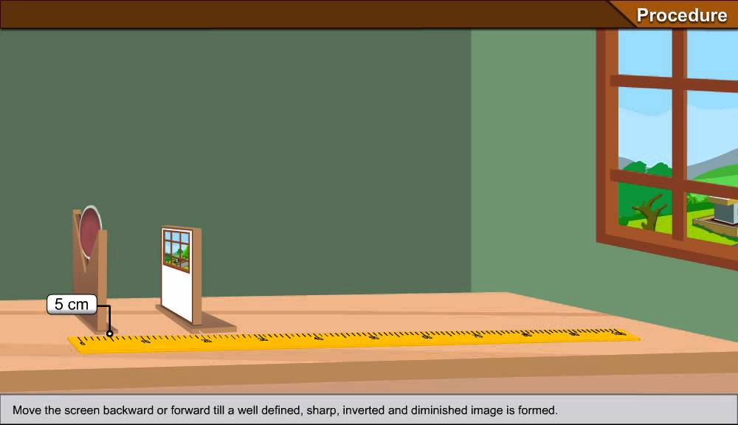
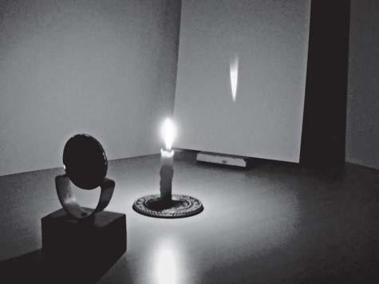

:
- V-
- 
- 
- 

- V-

- 
-  u
 v
-  $\frac{1}{f}$ = $\frac{1}{u}$ + $\frac{1}{v}$  f
NAGA MURTHY- 9441786635
Contact at : nagamurthysir@gmail.com
Visit at : ignitephysics.weebly.com

 :
- 
- 
 u v 
 :
-  $\frac{1}{f}$ = $\frac{1}{u}$ + $\frac{1}{v}$
$\frac{1}{ f}$ = $\frac{1}{………….}$ + $\frac{1}{…………….}$
$\frac{1}{ f}$ = $\frac{…………. + …………….}{……………………………………..}$
$\frac{1}{ f}$ = $\frac{…………. …………….}{……………………………………..}$
$\frac{1}{ f}$ = $\frac{…………. …………….}{……………………………………..}$
f

- 
- V-
- 

 :
-  
-  
- 

NAGA MURTHY- 9441786635
Contact at : nagamurthysir@gmail.com
Visit at : ignitephysics.weebly.com

