Date : CLASS-10 PHYSICAL SCIENCE
CHAPTER: 03 –REFRACTION BY DIFFERENT SURFACES
EXPERIMENT – 
FOCAL LENGTH OF CONCAVE MIRROR
Aim : Finding focal length of a given concave mirror with infinite distance method and
verify it with practical method.
Required : Concave mirror, V-stand, Screen, Measuring tape or meter scale, Candle, Match
box
Description : The point on the principal axis at which the parallel rays coming from infinity
converges after reflection is called focus of the spherical mirror. It is denoted by ‘F’.
The distance between pole and focus is called focal length of the spherical mirror. It
is denoted by ‘f’.
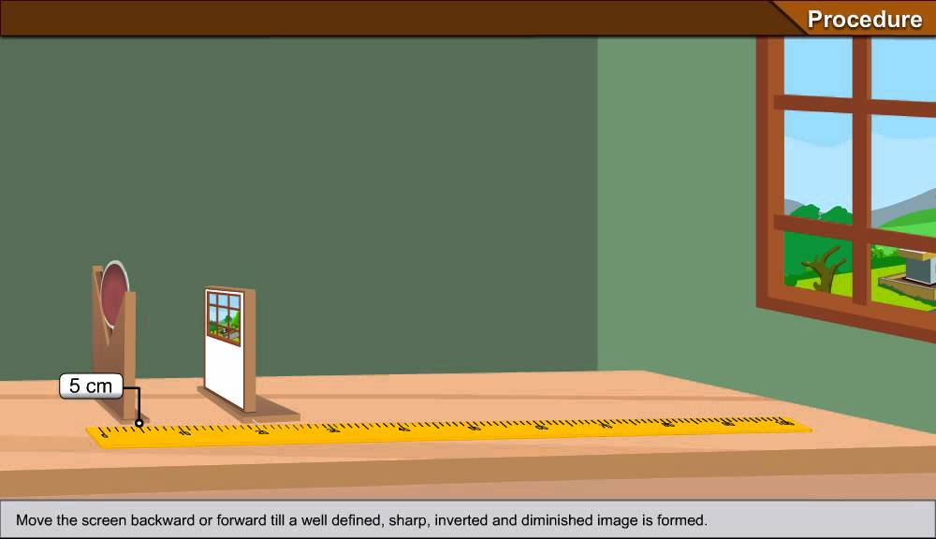
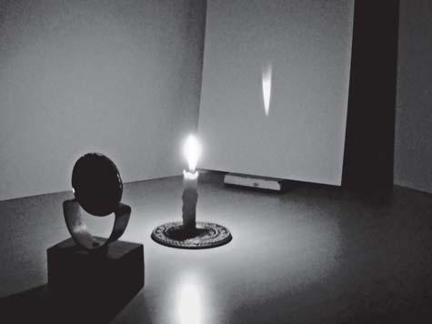

Formula : Object distance = u Image distance = v Focal length = f
Then Mirror formula : $\frac{1}{f}$ = $\frac{1}{u}$ + $\frac{1}{v}$
Procedure :
- Place concave mirror on V-stand.
- Arrange the mirror towards a tree which is at infinite distance (Long distance).
- Place the screen in opposite to the mirror and adjust the place of screen such that the clear image of tree can be collected on it.
- Measure the distance between the mirror and screen. This is focal length of the concave mirror. (The image of object which is at infinite distance can collected at Focus.)
- Now place the mirror n V-stand. Lit a candle in front of the mirror.
(It should be placed beyond focus of the mirror)
- Place the screen in opposite to the mirror and adjust the place of screen such that the clear image of tree can be collected on it.
- Measure the distance between mirror and candle as object distance ‘u’ and the distance between mirror and screen as image distance ‘V’ by using tape.
- Find the focal length of mirror by using formula : $\frac{1}{f}$ = $\frac{1}{u}$ + $\frac{1}{v}$
Observation :
- The focal length of concave mirror (f) = …………………………………
(Infinite distance method)
- In experimental method :
Object distance u = ………………… cm., Image distance v = ……………………… cm.
NAGA MURTHY- 9441786635
Contact at : nagamurthysir@gmail.com
Visit at : ignitephysics.weebly.com

Calculation:
- Mirror formula   $\frac{1}{f}$ = $\frac{1}{u}$ + $\frac{1}{v}$
                            $\frac{1}{ f}$ = $\frac{1}{………….}$ + $\frac{1}{…………….}$
                            $\frac{1}{ f}$ = $\frac{…………. + …………….}{……………………………………..}$
                            $\frac{1}{ f}$ = $\frac{…………. …………….}{……………………………………..}$
                            $\frac{1}{ f}$ = $\frac{…………. …………….}{……………………………………..}$
      Focal length f    
Precautions :
- Collect the clear image on the screen without parallax error.
- The distance ‘from mirror’ means ‘from the centre of V-stand’.
- Measure distances accurately.
Result :
- Focal length of given concave mirror = ……………………………
(Infinite distance method)
- Focal length of given concave mirror = ……………………………
(Experimental method)
- Found focal length of a given concave mirror with infinite distance method and verified it with practical method.
NAGA MURTHY- 9441786635
Contact at : nagamurthysir@gmail.com
Visit at : ignitephysics.weebly.com

