Date : CLASS-10 PHYSICAL SCIENCE
CHAPTER: 01 – HEAT
EXPERIMENT – 1
SPECIFIC HEAT OF SOLID
Aim : To find the specific heat of a given solid.
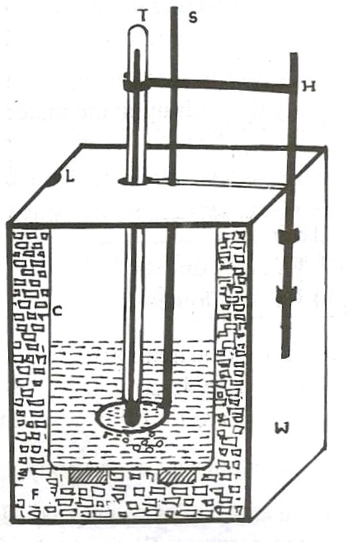
Required : Calorimeter, Laboratory thermometer, Water,
Hot water, Solid shots (lead shots)
Description :Calorimeter consists of a thin cylindrical copper vessel.
The copper vessel is placed in a wooden box. The gap
between vessel and wooden box is filled with insulating
material like wool / fur. The wooden box contains a
wooden lid. The lid has a slot that a stirrer is to be
immersed through it into the copper vessel. Also the
lid has a hole to immerse laboratory thermometer.
(It may also have an holder for thermometer at a side
of wooden box.)
Formula :When two or more bodies at different temperatures are brought into thermal
contact, then net heat lost by the hot bodies is equal to the net heat lost by the hot
bodies until they attain the thermal equilibrium.

Net heat lost by the hot bodies = Net heat gain by the cold bodies
Procedure:(1) First we have to find the mass of the calorimeter (vessel) (m₁).
(2) Fill nearly half of the calorimeter with water and find the mass of calorimeter with
water (m₂).
(3) Measure the initial temperature with laboratory thermometer (T₁ºC).
This is the temperature of both water and also calorimeter.
(4) Take a few lead shots and place them in hot water. Heat them up to
a temperature (nearly) 100ºC. So measure the temperature of lead shots (T₂ºC).
(5) Transfer the lead shots into calorimeter quickly with minimum loss of heat.
(6) Stir the mixture well.
(7) Note the final temperature (T₃ºC).
(8) Measure the final mass of calorimeter along with water and lead shots (m₃).
Heat (Q) = m.s.∆T
According to the method of mixtures :
Heat lost by the solid = Heat gained by calorimeter + Heat gained by water
(m₃-m₂).S_{l}.(T₂-T₃) = m₁.S_{c}.(T₃-T₁) + (m₂-m₁).S_{w}.(T₃-T₁)
$S_{l}$ = $\frac{\left[m_{1} S_{c}+{\left(m_{2}-m_{1}\right)S}_{w }\right][T_{3}-T_{1}]}{\left(m_{3}-m_{2}\right)(T_{2}-T_{3})}$
This way we can find the specific heat of a solid.
NAGA MURTHY- 9441786635
Contact at : nagamurthysir@gmail.com
Visit at : ignitephysics.weebly.com

Take S_{w} = 1 cal/gm -ºC
S_{c} = 0.095 cal/gm -ºC

Observation :
Mass of the calorimeter (copper vessel only) (m₁) = ………………… gm
Mass of the calorimeter with water (m₂) = ………………… gm
Mass of water (m₂ – m₁) = ………………… gm
Temperature of water in calorimeter (T₁) = …………………. ºC
Temperature of hot lead shots (T₂) = …………………. ºC
Mass of the calorimeter with water and lead shots(m₃) = ………….……… gm
Mass of lead shots (m₃ – m₂) = ………….……… gm
Final temperature of
calorimeter with water and lead shots (T₃ – T₂) = …………….….…ºC
Specific heat of water (S_{w}) = 1 cal/gm-ºC
Specific heat of copper calorimeter (S_{c}) = 0.095 cal/gm-ºC
Specific heat of lead shots (S_{ᶩ}) = ?
Calculation :
$S_{l}$ = $\frac{\left[m_{1} S_{c}+{\left(m_{2}-m_{1}\right)S}_{w }\right][T_{3}-T_{1}]}{\left(m_{3}-m_{2}\right)(T_{2}-T_{3})}$
$S_{l}$ = $\frac{\left[m_{1} (0.095)+{\left(m_{2}-m_{1}\right)1}_{ }\right][T_{3}-T_{1}]}{\left(m_{3}-m_{2}\right)(T_{2}-T_{3})}$

= ……………………………

= ……………………………

= ……………………………
Precautions :
- Transfer solid shots from hot water to calorimeter vessel quickly and carefully with minimum loss of heat.
Result :
- The specific heat of given lead shots is …………………… cal/gm-ºC.
NAGA MURTHY- 9441786635
Contact at : nagamurthysir@gmail.com
Visit at : ignitephysics.weebly.com

